DS1307 Real Time Clock IC Interfacing to Arduino:
Introduction:
DS1307 - Real Time Clock IC:
The DS1307 lets you explore I2C communication on the arduino.
I2C Communication
I2C is short form for 'Inter Integrated Circuit' I2C Communication is Communication Bus standard developed by Phillips for standardising Communication between Integrated Circuits. For Eg. In a circuit, there could be a number of ICs each offering specific functionality[RTC, Temperature Sensor, EEPROM, etc] and they can all communicate on a single I2C Bus and provide combined functionalities. Each device on the I2C Bus would have a unique address by which it can be addressed.

I2C on Arduino
The I2C Bus uses 2 lines for Communication - SDA(Serial Data) & SCL (Serial Clock). On the InduinoX / Arduino, these are available on SDA (Analog Input 4) & SCL (Analog Input 5). The I2C bus can be accessed using the 'Wire' Library of Arduino. First, lets try out a Library

Requirment:
- DS 1307 Real time clock IC,Crystal for DS1307, 2 x 10K Resistors
- Arduino Board
- Breadboard

Hardware configuration:
DS1307 Pin Mappings. SDA [Serial Data] / SCL [Serial Clock] correspond to lines for I2C Communication. We can ignore Vbat & SQW / OUT Pins.

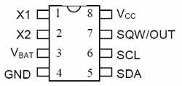

Step1:Place the DS1307 IC.

Step2: Connect a Wire from the 4th pin of DS1307 (GND) to the '-'ve terminal

Step3:Connect a Wire from the 8th pin of DS1307 (+5V) to the '+'ve terminal

Step4:Place the Cyrstal as shown between the 1st and 2nd pin of the DS1307 IC- There is no polarity ('+' / '-' ve) for the crystal. So you can place it anyway

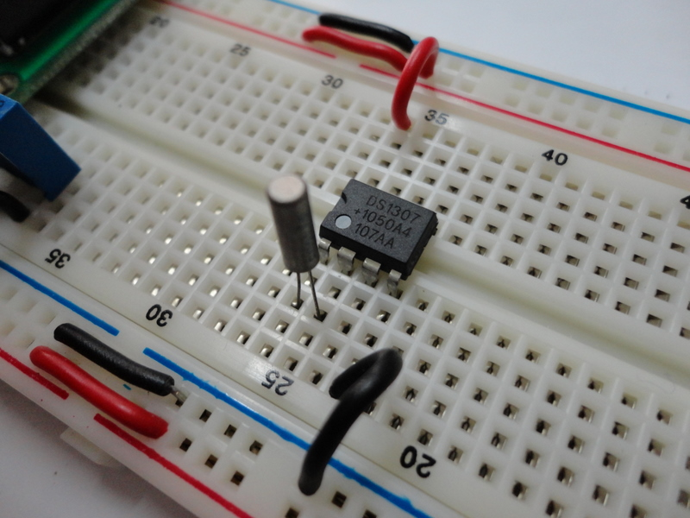

Step5:Place one resistor between the SDA Pin and the '+'ve terminal and one resistor between the SCL Pin and the '+'ve terminal

Step6:Connect a Wire between the SDA pin (pin5 of DS1307) and the SDA pin of the Arduino (Analog IN 4)

Step7: Connect a Wire between the SCL pin (pin6 of DS1307) and the SCL pin of the Arduino (Analog IN 5)

Final Setup with output as shown below.
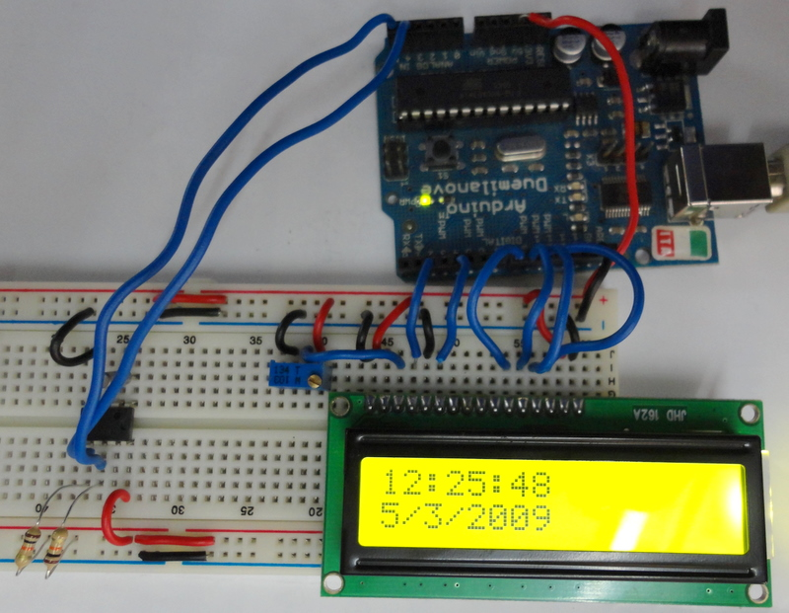

Programing:(source code):
*
This prograses the Wire Library (for i2c communication)
This program sets the initial time for the RTC and keeps updating the time on and LCDeverysecond.
*/

#include <Wire.h>
#define rtc 0x68// The pre-defined address for DS1307

int ss,mm,hh,d,DD,MM,YY,mode;
boolean time_format,meridiem;

int prev;
#include<LiquidCrystal.h>

// initialize the library with the numbers of the interface pins
LiquidCrystal lcd(2,4,8,9,10,11);

void setup()
{
Wire.begin();
lcd.begin(16, 2);
set_time();
}

void loop()
{
get_time();
if(ss!=prev) // lcd Print when the seconds change
{
lcd.setCursor(0,0);
lcd.print("Date:");
lcd.print(DD);
lcd.print("/");
lcd.print(MM);
lcd.print("/");
lcd.print(YY);
lcd.setCursor(0,1);
lcd.print("Time:");
lcd.print(hh);
lcd.print(":");
lcd.print(mm);
lcd.print(":");
lcd.print(ss);
prev=ss;
}
}

void get_time()
{
Wire.beginTransmission(rtc); // start communication over i2c with DS1307
Wire.write((byte)0); // Write the value of the register to point to
Wire.endTransmission(); // End communication over i2c with DS1307

Wire.requestFrom(rtc,7); // This will request 7 bytes of data
//starting from the '0' the register
ss=bcd_to_dec(Wire.read());
mm=bcd_to_dec(Wire.read());
hh=Wire.read();
time_format=hh&(1<<6);
meridiem=hh&(1<<5);// calculate am or pm
hh=bcd_to_dec(hh&0x1F);
d=bcd_to_dec(Wire.read());
DD=bcd_to_dec(Wire.read());
MM=bcd_to_dec(Wire.read());
YY=bcd_to_dec(Wire.read());
Wire.endTransmission();
}

void set_time()
{
time_format=0;// 0=24 hour mode, 1=12 hour mode
meridiem=1;// 0=am, 1=pm will not be taken into consideration if time format is 24 hour mode
mode=(time_format<<6)+((time_format&&meridiem)<<5);//calculate the bits to be added for 12 hour mode

Wire.beginTransmission(rtc);
Wire.write((byte)0);
Wire.write(dec_to_bcd(50)); // seconds
Wire.write(dec_to_bcd(59)); // minutes
Wire.write(mode+dec_to_bcd(11));// hours
Wire.write(dec_to_bcd(3)); // day of the week, startin monday
Wire.write(dec_to_bcd(21)); // date
Wire.write(dec_to_bcd(12)); // month
Wire.write(dec_to_bcd(11)); // year
Wire.endTransmission();
}

int dec_to_bcd(int dec)
{
return dec/10*16 + (dec%10);
}

int bcd_to_dec(int bcd)
{
return bcd/16*10 + (bcd%16);
}

Installation:
The source code copy to the skeches of arduino and compile (there is verify option) as shown given below.
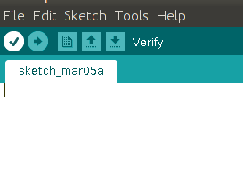

And then uploding the source code.(there is uploding option) to the Arduino board.(software) as shown given below.
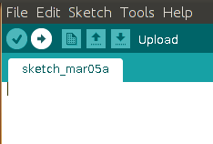

Troubleshooting:
FAQ:

Maintainers:
Duryodhan Aldar (durva.ges@gmail.com)

References: http://quickstartkitforarduino.blogspot.in/

